SET 13 – GEOGRAPHIC DATA ANALYSIS
Aim
To analyze geographic data using a map-style chart, scatter plot, and table in R.
Algorithm
- Create the geographic dataset containing city, population, temperature, and elevation.
- Assign simple latitude and longitude values for visualization.
- Create a map-style plot showing city locations.
- Create a scatter plot between population and average temperature.
- Display the geographic data in a table.
R Program
library(ggplot2)

geo <- data.frame(
City=c("City A","City B","City C"),
Population=c(500000,700000,600000),
Temperature=c(75,68,80),
Elevation=c(1000,800,1200),
Longitude=c(78,79,80),
Latitude=c(13,14,12)
)

ggplot(geo, aes(Longitude, Latitude, size=Population, label=City)) +
geom_point() +
geom_text(vjust=-1) +
labs(title="Geographic Distribution of Cities",
x="Longitude", y="Latitude")

ggplot(geo, aes(Population, Temperature)) +
geom_point() +
geom_text(aes(label=City), vjust=-1) +
labs(title="Population vs Average Temperature",
x="Population", y="Average Temperature")

print(geo)

OUTPUT:
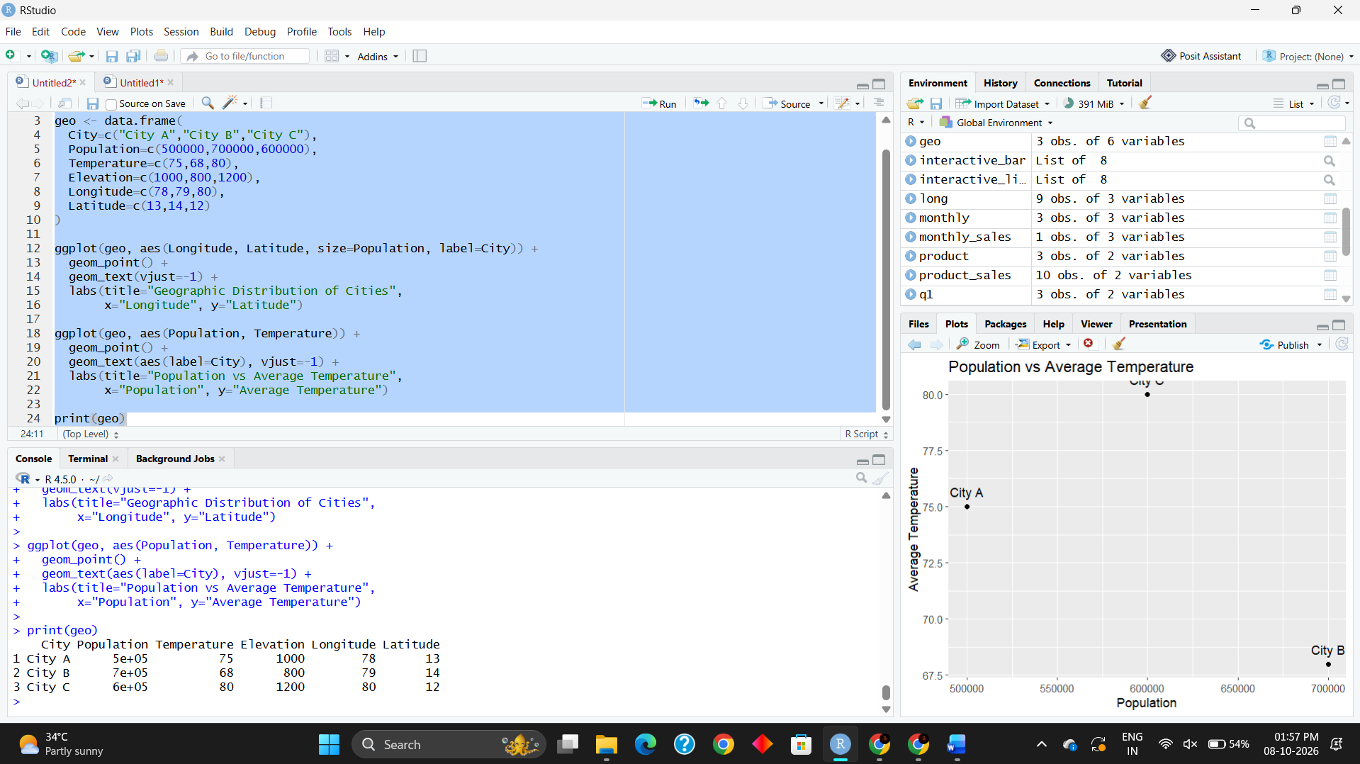
Result
The map-style plot successfully represents the geographic distribution of the cities. The scatter plot shows the relationship between population and average temperature, and the table displays the geographic information.

